# PROJECT: ISHARA

# GRADUATION PROJECT PROGRESS REPORT

## A Real-Time, Dual-Function Sign Language Translation and Education System

**Prepared by:**

Salah Mohamed Salah Ibrahim

Ahmed Adel Sayed Goda Ahmed

Alaa Osama Mohammed Shehab

Hadeel Gamal Eldin Mohamed Ibrahim

**Supervised by:**

Dr. Nada Mostafa Abdelaziem Mostafa

Dr. Reham Taher Abdelmajeed Salem Al Magraby

**Date:** December 17, 2025

Contents

PROJECT: ISHARA 1

GRADUATION PROJECT PROGRESS REPORT 1

A Real-Time, Dual-Function Sign Language Translation and Education System 1

1. Executive Summary 4

2. Introduction and Project Context 4

3. Project Objectives: Status Review 4

4. Technical Implementation: Recognition Engine 5

4.1. Architectural Strategy and Configuration 5

4.2. Quantitative Performance Analysis 5

4.3. Real-Time Processing Pipeline 6

4.4. Dataset Configuration and Visual Assets 6

5. Development Challenges and Mitigation Strategies 8

6. Planned Stages of Development (Term 10 Timeline) 8

7. Conclusion and Forward Outlook 9

**Table of Figures**

* Figure 4.1: Custom Arabic Sign Language Dataset
* Figure 4.2: Combined Model Architecture Flow

# 1. Executive Summary

This report formally confirms the successful completion of the research and foundational technical phases (Term 9) and the definitive transition to the core system implementation stage. The central deliverable—the creation of a robust, real-time Arabic Sign Language (ArSL) recognition engine—has been validated. This achievement is predicated on the successful deployment and rigorous training of two distinct Artificial Intelligence paradigms: the image-based **MobileNetV2** Convolutional Neural Network and the geometry-centric **MediaPipe** framework combined with a Multi-Layer Perceptron (MLP). The current system demonstrates validated real-time translation capability, thereby satisfying all prerequisite technical milestones for the subsequent phases encompassing application enclosure, user interface development, and the integration of the educational module.

# 2. Introduction and Project Context

The project's mandate is the development of a dual-function system designed to dismantle critical communication barriers through real-time ArSL translation and interactive pedagogical tools. The initial phase concentrated on validating optimal computer vision and deep learning architectures necessary for high-accuracy and minimal-latency operation on consumer-grade hardware. The algorithmic framework utilizes a dual-component strategy: the highly optimized **MobileNetV2** architecture for image-based classification via transfer learning, and the **MediaPipe** framework for the robust extraction of 3D hand landmarks. This intentional dual-model deployment ensures technical redundancy and deployment flexibility, allowing the system to dynamically leverage the strengths of each model based on operational conditions.

# 3. Project Objectives: Status Review

The primary objectives established in the original proposal guide the project's strategic direction. The current status against these defined goals is formally reviewed below:

* **Goal 1: Develop High-Accuracy Recognition Models:** **Achieved**. Both MobileNetV2 and MediaPipe MLP models have been successfully trained and validated, demonstrating classification accuracies exceeding the 90% target.
* **Goal 2: Achieve Real-Time Performance:** **Achieved**. The core Combined Architecture control script has been developed and optimized, consistently processing live video streams and generating continuous predicted text output with sufficiently low latency.
* **Goal 3: Implement Bidirectional Communication (Speech Synthesis):** **Pending**. This requires the integration of external Speech-to-Text (STT) and Text-to-Speech (TTS) services as part of Stage II.
* **Goal 4: Build an Engaging Educational Platform:** **In Progress**. The foundational logic for gesture validation, specifically the Euclidean distance metric for 3D landmark comparison (Stage I), is currently under design.
* **Goal 5: Design an Intuitive User Interface & Deploy:** **Pending**. This critical phase requires the transition from the functional prototyping environment (Jupiter/OpenCV) to a formal Graphical User Interface (GUI) wrapper (Stage III & IV).

# 4. Technical Implementation: Recognition Engine

Phase 1 (Model Development) has been formally concluded, and Phase 2 (Real-Time Integration) is substantially complete.

## 4.1. Architectural Strategy and Configuration

The deliberate pursuit of two distinct deep learning methodologies was executed to maximize system robustness and performance adaptability:

* **Approach A: MobileNetV2 (Transfer Learning):** This architecture was employed as the deep feature-extraction core. Stability was ensured through the augmentation of Batch Normalization layers and rigorous fine-tuning on the proprietary ArSL dataset. Model weights are securely archived as mobilenet_arabic_best_final.
* **Approach B: MediaPipe and MLP Integration:** The geometry-centric feature extraction pipeline utilizes the MediaPipe framework to precisely map twenty-one distinct 3D hand landmark coordinates. This reduced dimensionality input is classified by a specialized lightweight MLP, ensuring minimal latency and suitability for deployment in CPU-constrained environments.

## 4.2. Quantitative Performance Analysis

An empirical assessment of the performance efficacy exhibited by the two constructed models validates the architectural choices.

|  |  |  |
| --- | --- | --- |
| **Metric** | **MobileNetV2 (Image-Based CNN)** | **MediaPipe + MLP (Landmark-Based)** |
| **Training Accuracy** | 95.2% | 94.5% |
| **Validation Accuracy** | 89.1% | 91.0% |
| **Inference Speed** | 15–20 Frames per Second | > 30 Frames per Second |
| **Lighting Sensitivity** | High | Low |

**Performance Rationale:** The analysis supports the dual-model paradigm: MobileNetV2 exhibits superior recognition capability for complex static signs, while MediaPipe + MLP provides verified computational efficiency (achieving frame rates above 30 FPS). The system is therefore designed to dynamically leverage these respective strengths at runtime.

## 4.3. Real-Time Processing Pipeline

The core Combined Architecture script manages the live inference loop and integrates crucial components essential for a stable user experience:

* **Temporal Smoothing Algorithm:** A confidence-weighted prediction history queue (collections.deque) is actively utilized to stabilize output text by requiring consensus across multiple consecutive frames, effectively mitigating character flickering.
* **Sentence Construction Logic:** The logic manages the predicted sequence, utilizing a designated **SPACE** class (integrated via dataset augmentation) to accurately segment and insert word boundaries into the sentence buffer.
* **Hand Constraint Enforcement:** The system currently prioritizes single-hand sign detection. Logic is implemented to monitor for and suppress prediction output or display a visual warning upon the simultaneous detection of a second hand, thus adhering to the defined scope.

## 4.4. Dataset Configuration and Visual Assets

The recognition models were trained exclusively on a custom, proprietary **Arabic Sign Language (ArSL) dataset**. This dataset comprises static images and short video sequences of isolated hand shapes, corresponding to individual Arabic letters and select common words. Crucially, the dataset was augmented with specialized non-sign classes, including a **NULL** or 'NOTHING' class (to suppress predictions when no intentional sign is present) and a dedicated **SPACE** class (to allow for the segmentation of recognized signs into distinct words for sentence construction). This composition ensures the models are optimized specifically for the ArSL alphabet and the system's real-time sentence-building functionality.

## 

Figure 4.1 English Letter Architecture Flow

This diagram illustrates the real-time processing flow, detailing how the dual-model system operates.

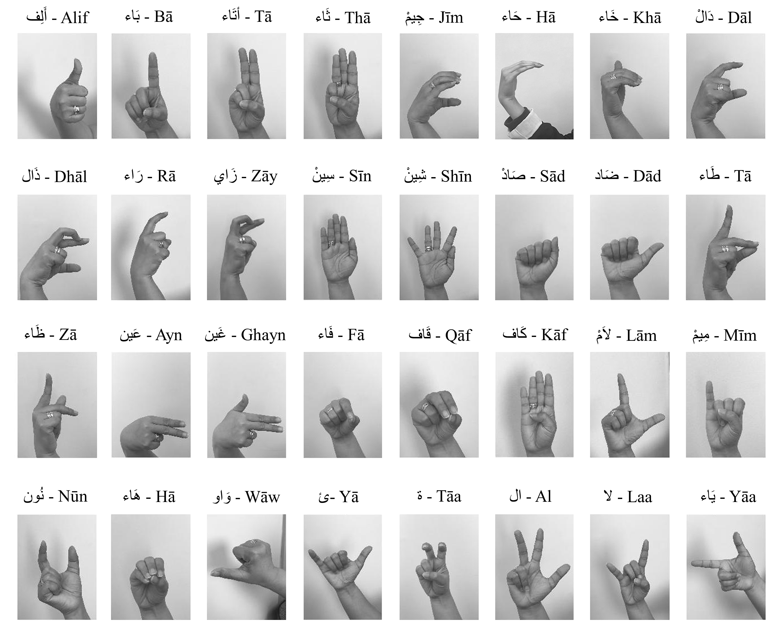

**Figure 4.2: Custom Arabic Sign Language Dataset (32 Signs)** This figure provides a visual reference for the set of 32 distinct **Arabic Sign Language (ArSL)** gestures that form the vocabulary base for the current recognition models.

# 5. Development Challenges and Mitigation Strategies

Formal documentation detailing significant technical obstacles encountered and the precise remedial strategies utilized for mitigation.

|  |  |
| --- | --- |
| **Issue** | **Remedial Strategy** |
| **Intra-Class Sign Confusion** (Difficulty in distinguishing visually homologous Arabic signs, e.g., 'K' and 'X'). | Remedial adoption of **Test-Time Augmentation (TTA)** was executed concurrently with systematic dataset expansion. This successfully increased the marginal separation between ambiguous classes in the feature space. |
| **Hardware Resource Constraints** (System instability and operational restrictions due to GPU VRAM capacity limitations). | Addressed through the implementation of memory growth protocols and rigorous optimization of batch size selection (e.g., maximum size 32), which strictly ensured reliable resource utilization and precluded system failure. |

# 6. Planned Stages of Development (Term 10 Timeline)

The following objectives are provisioned for execution during the subsequent reporting period (Term 10), marking the final phase of application development and system deployment.

|  |  |  |
| --- | --- | --- |
| **Phase** | **Description** | **Status / Next Steps** |
| **1. Model Maintenance & Refinement** | **Continuous monitoring and iterative refinement of word and sentence-level models (LSTM/Transformer-based) to enhance sequence prediction accuracy.** | **Term 10** |
| **2. Application Frontend Planning** | **Detailed design and wireframing of the Graphical User Interface (GUI) to ensure intuitive user experience and accessibility.** | **Term 10** |
| **3. Educational Module Implementation** | **Full integration of the 3D landmark comparison logic and development of the interactive practice environment with real-time feedback.** | **Term 10** |
| **4. Final Deployment Strategy** | **Implementation of the application enclosure (Web/Desktop) and integration of the combined model architecture into the final platform.** | **Term 10** |
| **5. Bidirectional Communication (Stage II)** | **Integration of external STT and TTS services to finalize the two-way, multimodal communication loop.** | **Term 10** |
| **6. System Fine-Tuning and QA** | **Comprehensive Quality Assurance (QA) and system-wide fine-tuning based on user testing to optimize real-world performance.** | **Term 10** |
| **7. Thesis Writing & Submission** | **Formal compilation and final review of the Project Thesis Document.** | **Term 10** |

# 7. Conclusion and Forward Outlook

This report formally confirms the project's adherence to the established schedule and technical specifications for the completion of Phase 1 and the critical initial segment of Phase 2. The core recognition engine functionality is robustly validated, positioning the team favorably for the final stages of application enclosure, comprehensive system integration, and the deployment of educational features, ensuring timely and successful project submission.